Omaha Force Wood Bat Classic
T-SHIRT ORDER FORM

(SHIRT IS A PERFORMANCE T, A-4 STYLE/BRAND)

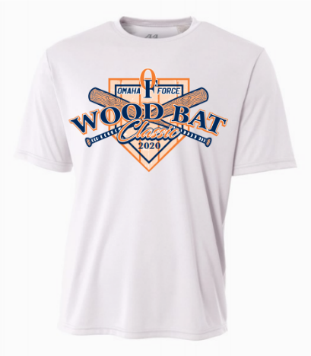

$20 PER SHIRT ADD $3 FOR 2XL AND UP...

SIZE TOTALS FOR EACH SIZE:

YM:____YL: ____YXL:____S: ____M: ____L:_____XL: ____2XL: ____ 3XL: ____ 4XL: ____

Payments: Paypal to: steve@omahaforce.com
Venmo: @Steve-Stamm-1
Checks: made payable to Omaha Force 10456 Chandler Cr. Suite 103 La Vista, NE 68128
Credit cards can be taken over the phone: 402-968-6141
EMAIL STEVE@OMAHAFORCE.COM FOR ANY QUESTIONS…

